
{
Planning Student Organization Events
OHIO UNIVERSITY

Welcome

For students that are newly elected to positions of leadership, planning an event for their peers can be daunting. There are multiple departments, units, and full time staff members with whom they will communicate by the close of the event. Recruitment, meetings, awards, special speakers, and end of year recognition are only a few of the categories for the organizations, and they might plan multiple events each year. This training manual gives them the resources to plan, accomplish, and complete a successful event at Ohio University.
Included will be an outline with timeline for which to contact and confirm the details of their event. Also listed within the manual are the offices and contact information for their convenience.
Ohio University’s mission is to forward the intellectual and personal development of its students. With this training, they will be better prepared to orchaestrate events at
Ohio University, and beyond.
CONTENTS
 Training Rationale…………………………………………….………pg X
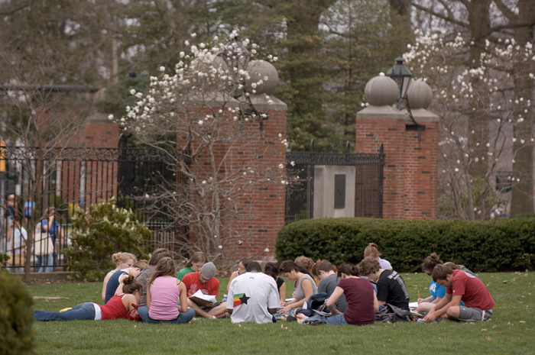 Target Audience…………………………………………….…………pg X
 Learning Objectives………………………………………….……..…pg X
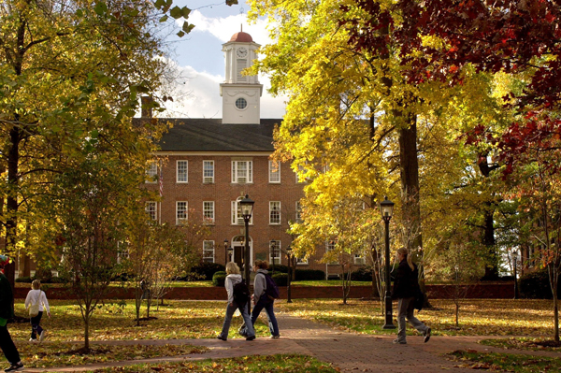 Equipment & Materials/Presentation Timeline……………………pg X
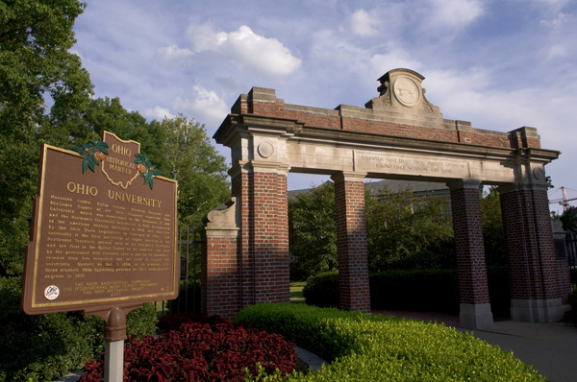 Training Content & Instruction Method……………………………pg X
 Trainers Instructions………………………………………................pg X
 Evaluation Quiz & Answers…………………………………………..pg X
 Trainer’s Evaluation………………….………………………………..pg X
 Annotated Bibliography……………………………………………....pg X
Training Rationale
After conducting a Needs Assessment with the COMS 6270 class, it became clear that while many students had planned events in the past, they did have shared concerns. The three most frequent were where to begin, time management, and keeping track of contracts while budgeting for the event. Most said that they would be comfortable planning an event for 5-45 people, but when the numbers grew, confidence diminished. While planning small and medium events can be easily managed, difficulty multiplies exponentially when the numbers grow. I propose that this training focus on how to plan large events on the Ohio University campus in Athens, OH.
Large events are especially important for a basic reason: More people will be in attendance. Typically, sessions that host such grand numbers are especially important as well. They can range from massive dinners to lectures, but in each case a huge amount of planning and specific execution are necessary. Training for this type of event coordination is important so that the trainee is prepared for any event that arises at the last minute, or if the initial coordinator must step down and a replacement is needed. Because the students will be communicating with multiple university departments, it is also necessary that the proper avenues are clearly laid out for them.

Target Audience

In the field of Organizational Communications, those holding people-orientated roles are frequently the individuals chosen to organize events. In Human Resource positions they are structuring training sessions, management seats and discussing corporate functions, or part of a committee to celebrate achievements. Regardless of the occasion, Organizational Communications students will be called upon to complete a wide range of tasks, and the ability to step up to varied challenges is especially helpful in today’s marketplace. This training will be another skill that the students will be able to use when necessary to prove their abilities as effective communicators in their chosen professions.

Learning Objectives

- Be able to use a planning worksheet to organize event needs.
- Be capable of delegating specific tasks that must be accomplished for event implementation.
- Be able to organize vendor contracts and payments to conclude an event.
- Demonstrate learned skills by completing a quiz on planning events at Ohio University.
Equipment & Materials Checklist

_ Training Manual _ Worksheets _ Pencils
_ Computer _ PowerPoint _ Projector
_ Projection Screen _ Participant Guide

Presentation Timeline
Introduction : 2 min
How to Plan an Event: 7 min
How to Execute an Event: 7 min
How to Close an Event: 7 min
Review: 4 min
Open Questions: 3 min

Training Content & Instruction Method

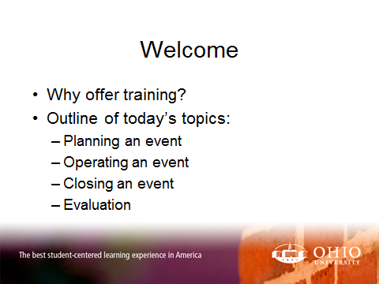

- Ohio University Students are subject to many policies and rules when holding events on Campus.
- They will contact and work with multiple departments and units, along with full time staff.
- Understanding the right office to contact, in the correct order, and who to call for specific questions will help you have an outstanding expereince.
- There are three steps to successful events: Planning, Operating, Closing.
- An evaluation will follow to ensure that the information was absorbed.

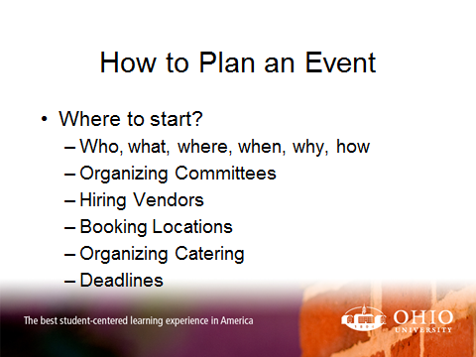
- Begin with the basics:
  - Who will be in attendance, how many total, and which groups?
  - What type of event: Catered dinner, reception, meeting?
  - Where will you hold it? What is available?
  - When can you have your event, and what time works best?
  - Why are you having it? What is the occasion? Orientation, Graduation?
  - How are you paying for it? What is your budgeet
- Organize committees to best utilize your group.
  - Divide and Conquer: Location, Food, Set-up, Facilitation, Tear-Down
- Hire any vendors you may need
- Book your location first through Event Services
- Order Catering, unless you qualify for an exemption
- Work within the deadlines of these departments
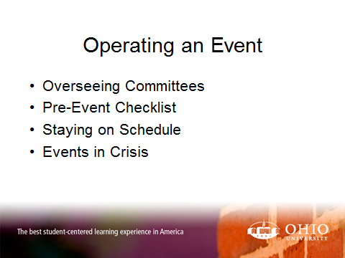
- Work with the leaders of the committees to make sure deadlines are met. Make sure everyone has a clear outline of duties for the day of the event.
- Run through your pre-event checklist
- Configure a schedule and share it with those presenting. Have a plan in case it runs long or short.
- Know who to call in the case of difficulty. Tech support, building managers, catering

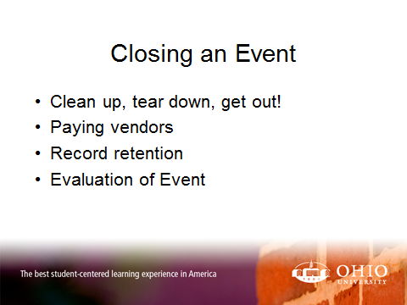
- Know what your timeframe is for clearing the room, and what you need to do
- Find vendors to ensure that payment was made. Check your reports to show that correct amounts were withdrawn
- Retain your records of contracts, event worksheets, etc.
  - This will help you with all future events
- Ask for feedback from group members about the event
  - Find out what went well, and what didn’t
  - Get ideas for future events
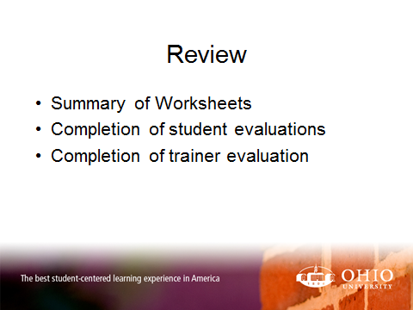
- Review the three steps to event planning at Ohio University
  - Planning an event
  - Operating an event
  - Closing an event
- Explain how to use the worksheets in the back of the Trainee Manual
- Complete Student Evaluations
- Complete Trainer Evaluations
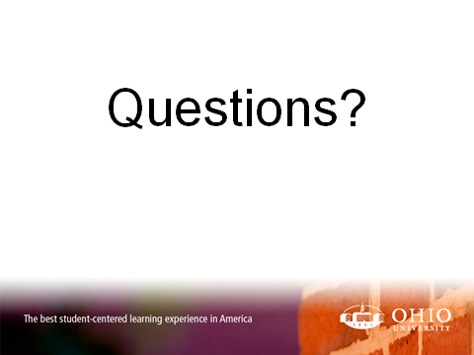

- Be sure to write any questions from students, in case they can be added to future presentations.
- If you’re unsure of an answer, offer to meet with the student afterward to further discuss the question. Offer to contact him or her with the answer.
Trainer’s Instructions
This training session is designed to last for 30 minutes, due to limited availability with the students. It is meant to introduce basic event planning at Ohio University for student groups. Please be mindful that the students are attending many training sessions today, and will likely feel overwhelmed. Participation will be difficult, as will drawing questions from them. Don’t be discouraged. The worksheets and information you give them today will be utilized later when they are in the throes of event planning.
Introduction : 2 min
Welcome the students, name the presentation, and explain that this will help them plan student organization events at Ohio University. Intrduce yourself, position, and establish credibility by explaing your role in event planning on campus. Follow the Training Content beginning on page 7 for the remainder of the training.
How to Plan an Event: 7 min
How to Execute an Event: 7 min
How to Close an Event: 7 min
Review: 4 min
Allow students to write answers in their manuals for the quiz, then go over the answers.
Open Questions: 3 min

Evaluation Quiz & Answers
- What tools are available to help you in the planning process?

- Trainer’s Evaluation

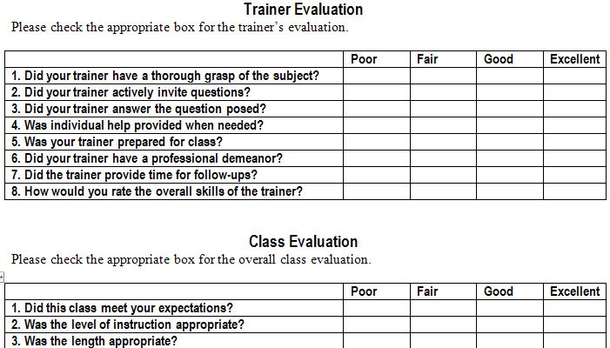

Please feel free to compose additional comments below:
Notes:

